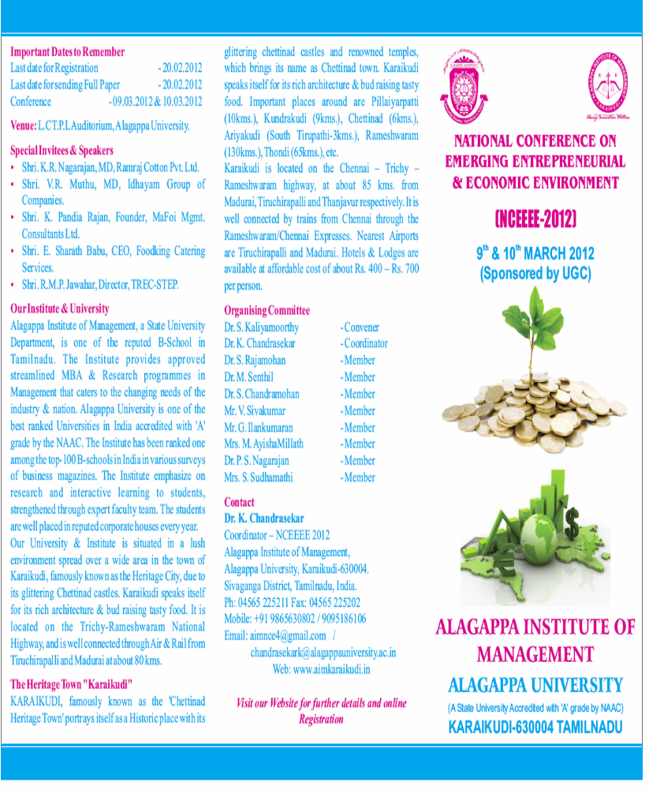
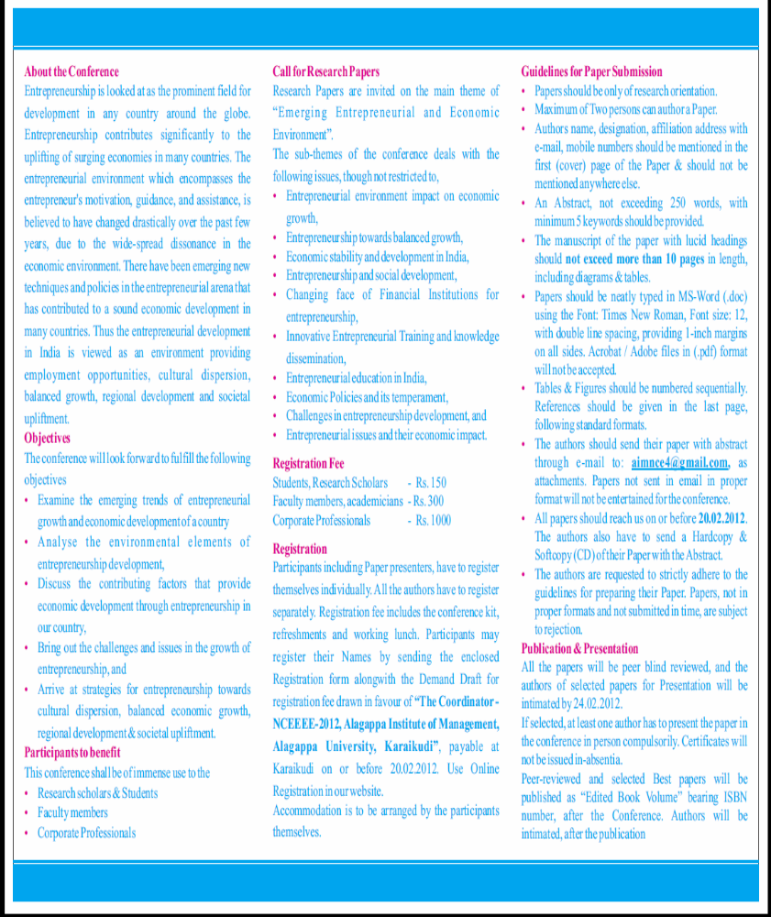


NATIONAL CONFERENCE ON
EMERGING ENTREPRENEURIAL & ECONOMIC ENVIRONMENT (NCEEEE-2012)
9th & 10th MARCH 2012
(Sponsored by UGC)

REGISTRATION FORM
Name of the author(s) : ____________________________________________
Designation : ____________________________________________
Qualification : ____________________________________________
Institution : ____________________________________________
Mailing address : ____________________________________________
____________________________________________
____________________________________________
________________________ Pin : ________________

Mobile / Phone number : _____________________________________________
E-mail id : _____________________________________________
Title of the paper : _____________________________________________

Payment Details
DD No. & Date : _____________________________________________
Name of the Bank : _____________________________________________
Branch & Place : _____________________________________________________
Amount : _____________________________________________

Place:
Date: Signature

Completed Registration Forms alongwith DD may please be mailed to
Dr. K. Chandrasekar
Coordinator – NCEEEE 2012
Alagappa Institute of Management, Alagappa University,
Karaikudi-630004. Sivaganga District, Tamilnadu, India.
Mobile: +91 9095186106 Fax: 04565 225202
Email: aimnce4@gmail.com Web: www.aimkaraikudi.in
Visit our Website for further details and online Registration

